Name ___________________
ACTIVITY 7-4
WHO ARE THE PARENTS?

Directions: Complete the steps for the activity listed in your textbook. Record your results in the table and answer the questions.

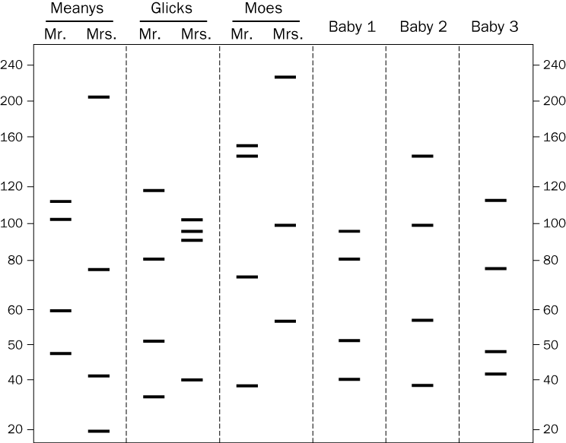

Questions:
- Which baby belongs to the Meanys?

- Which baby belongs to the Glicks?

- Which baby belongs to the Moes?

- Is it possible for a child to have a DNA band that is not found in the mother’s DNA? Explain your answer.

